1. What is software? What is software engineering?

* The software is basically a set of instructions or

commands that tell a computer what to do.

Software engineering is the process of developing, testing, and maintaining software to solve real-world problems using software.

1. Explain types of software.

Software can be broadly categorized into two main types system software and application software.

System software includes operating systems like Windows or macOS, which manage the computer's hardware and provide a platform for running other software.

Application software, on the other hand, includes programs like Microsoft Office or Adobe Photoshop, which are designed to perform specific tasks for the user.

1. What is SDLC? Explain each phase of SDLC?

* SDLC stands for Software Development Life Cycle, which is a process used by software developers to design, develop, and test software applications. The phases of SDLC include:

1. Planning: In this phase, the project scope, requirements, and objectives are defined.

Example: A team of developers creating a new mobile app will outline the features and functionalities they want to include in the app.

2. Analysis: During this phase, the team analyzes the

requirements gathered in the planning phase and creates a detailed project plan.

Example: The developers will break down the features of the app into smaller tasks and assign them to team members.

3. Design: In this phase, the team creates a blueprint for the software based on the requirements and specifications gathered in the previous phases.

Example: Architects creating blueprints for a building before construction begins.

4. Implementation: This phase involves coding and development of the software based on the design specifications.

Example: Programmers writing the code for the app based on the design document.

5. Testing: In this phase, the software is tested for bugs and errors to ensure it meets the requirements and functions properly.

Example: QA testers running various tests on the app to identify any issues.

6. Deployment: The software is deployed to the production environment and made available to users.



1. What is DFD?



ANS DFD is data flow diagram DFD is a graphical representation of the flow of data through a computer system of diagram

Create a DFD diagram on Flipkart?

Level 0 dfd of login in Flipkart

# 

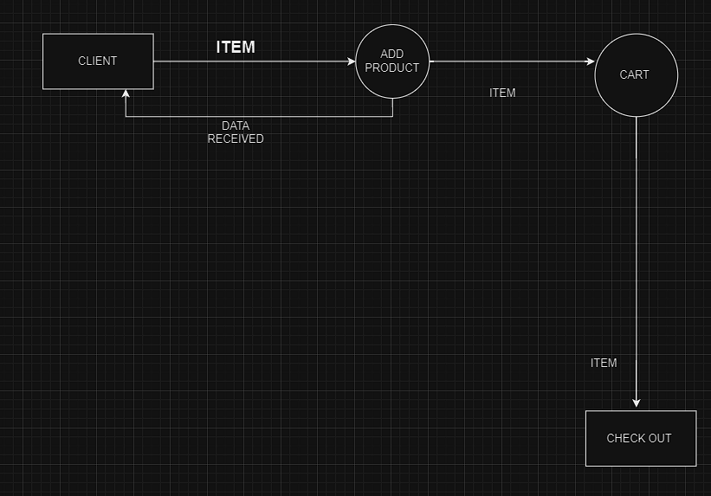 Level 1 DFD of add to cart in Flipkart 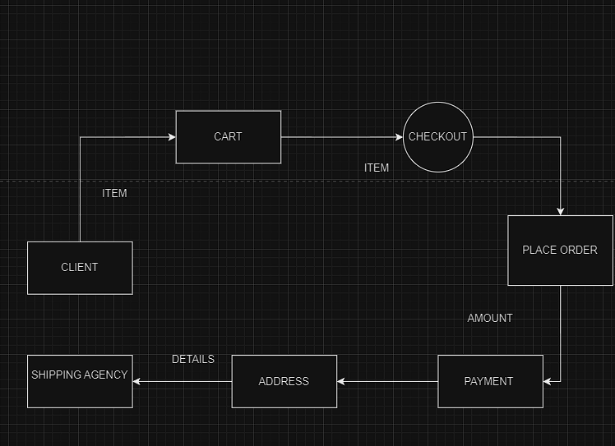 Level 2 DFD diagram of buy a item in Flipkart

1. what is flow chart ?

Ans flow chart is diagram that represents process

Create a flowchart to make addition of two numbers?

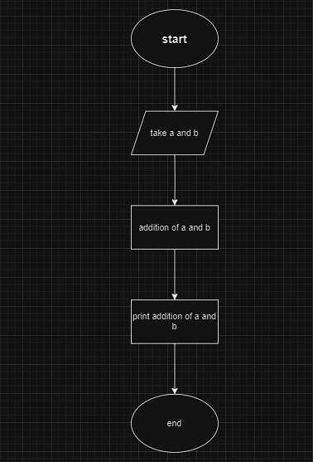

1. What is use case diagram

Ans use case diagram is a ghaphical depiction of use r possible Interaction with system

Create a use-case on bill payment on paytm.

